February 14, 2023

All Bidders

Re: Orchard View Middle School – Addendum FS1

Addendum Items:

The bid date has been extended to February 21, 2023 @ 11:00 am. Bids shall be delivered to the Middle School Central office located at 35 S. Sheridan, Muskegon, MI. prior to 11:00 am. A public bid opening will be held immediately following.

End of Food Service Equipment Addendum FS1 Items

I trust this is the information you require. If you have questions, please contact our office.

Sincerely,

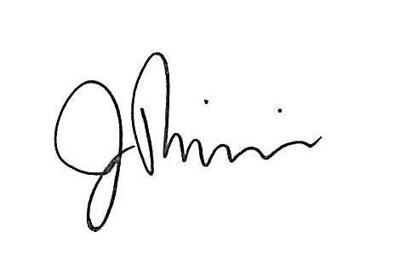
James Riemenschneider

President – JRA Food Service Consultants, LLC

